Draft Invitation for ACH Backbone Letters of Interest

Background

The partnership working to establish a North Central Accountable Community of Health (NCACH) must determine during 2015 the manner in which administrative support and related services (called Backbone Support Functions) will be provided for NCACH after its formal designation as an ACH in 2016. The NCACH Leadership Group is working under HCA Design Grant funding to address this and other issues in an effort to lay the groundwork for a successful Accountable Community of Health in our area. Further information on ACHs from the Health Care Authority is attached.

Backbone Support Functions are needed to enable NCACH to serve as an effective partner with state agencies in upcoming health care reform initiatives, and to act as an effective advocate for our communities as we cope with these changes. Backbone Support Functions include the following activities conducted under Governing Board direction:

- As a public or nonprofit entity, apply for, accept, manage and be accountable for funding from state agencies and other sources to address NCACH objectives.
- Hire and supervise NCACH staff.
- Support NCACH’s participation in monitoring and evaluation efforts regarding ACH functions, care improvement, and population health improvement.
- Develop proposals for funding and for other purposes.
- Produce reports on Community Health Needs Assessments, Community Health Improvement Plans, and other NCACH topics.
- Provide staff support to the Governing Board and its standing committees, to the Advisory Council, to the Coalitions for Health Improvement, and to other workgroups or committees that are part of the NCACH effort.
- Support the Governing Board in developing options for sustainability and fundraising as Federal start-up funding diminishes.
- Develop communication tools and documents for use in communicating about ACH purposes and initiatives with stakeholders and with the public.
- Organize meetings and conferences that advance NCACH goals.
- Collect and analyze data on health and health care in NCACH communities, interfacing effectively with state-level resources including the all payer’s database.
- Facilitate effective relationships among key NCACH stakeholders and with state agencies and programs, such as the Practice Transformation Support Hub.
Any public or nonprofit entity could provide these services given appropriate agreements with NCACH allowing effective oversight of ACH functions by the NCACH Governing Board. More than one organization could be involved in providing these services. For example, one organization could provide data collection and analysis services while a second organization could provide the other backbone services. Another option is to form a new nonprofit entity to provide ACH Backbone Support Services. It is important that any backbone support organization be considered a neutral party capable of convening the wide variety of partners involved in the ACH’s work. The purpose of this invitation is to determine what North Central Washington organizations, if any, are interested in exploring the possibility of becoming the NCACH backbone organization. No commitment is requested at this point. The point of this invitation is only to open a discussion with organizations interested in the possibility.

This invitation is being circulated widely to include as many community organizations and agencies as possible. If you have questions or would like to discuss this further, please feel free to contact any of these Leadership Group members:

Who?

To indicate an interest in the possibility of providing Backbone Support Functions, please send a letter or email indicating that interest to:

Who?

It is requested that letters be submitted by May 31, 2015.
The Proposed Role of Accountable Communities of Health in Washington State

Accountable Communities of Health (ACHs) are a precondition to achieving better health, better care and lower costs under the Healthier Washington initiative.

      - ACHs are designed to implement the following proposed strategies:
- Build upon existing community-based health improvement coalitions, leveraging and enhancing the relationships, commitments, and initiatives already in place to ensure a diverse, multi-sector approach to health and health care. The precise organizational and governance structure will not be dictated at the state level. ACHs will utilize a “collective impact” model to guide development.
- Strengthen community linkages between the local health care delivery system, public health, and others who influence a community’s physical and social environments, better informing and coordinating the priorities of each and placing a greater emphasis on social determinants of health and population health improvement.
- Formally connect health innovation and transformation efforts at the state and local level, allowing each to focus on its strengths, and leverage shared resources.
- Coordinate and connect at the regional and local level the delivery of the range of health care services and community and social supports contributing to individual and community well-being.
- Be a resource that managed care organizations draw upon to meet the state’s new expectations as it transitions medical assistance programs more rapidly from payment for particular health care services to payment for improved outcomes.
- Evaluate and elevate health innovations happening at the local level and facilitate the sharing of information about successes and failures statewide, enabling replication of success and avoidance of failures.

- Utilizing the functions introduced above, ACHs will accomplish the following goals:
- Leverage the unique strengths of the region by providing a strong and organized local voice to tailor and adapt state health care purchasing, delivery system reform and other health improvement activities within a region so programs are responsive to the unique strengths and needs of the region.
- Implement regional strategies and interventions set forth in the Plan for Improving Population Health. Engage and mobilize its multi-sector members in implementation.
- Accelerate the integration of physical and behavioral health care at the financing and delivery system level, starting with Medicaid, and inform the reinvestment of shared savings to support the community.
- Invest in promising and evidence-based practices and evaluating the results, scaling and spreading effective models, and capturing savings for reinvestment and sustainability through statewide learning collaboratives and testing innovative financing mechanisms.
- Address community health needs with the use of innovative data. ACHs will be armed with health mapping capabilities that will leverage improved statewide data analytics and integration.
- Partner with the state in successful achievement of quantitative and qualitative measures targets set as bars of success, specifically those tied to population health improvement and scaling efforts statewide.
- Amplify the role and responsibility of multiple sectors in health improvement to further address the social determinants of health.

- What is the relationship between ACHs and Risk-Bearing Entities?
As indicated in the illustration below, the relationship between ACHs and risk-bearing entities is as follows:
- The geographic area of an ACH will align with Regional Service Areas (RSA) for Medicaid purchasing and it is likely there will only be one ACH per RSA.
- Whether an RSA decides to be an early adopter (integrated purchasing in 2016) or a transition region (integrated purchasing by 2020), the ACH will be actively engaged in health improvement initiatives within the RSA and work in partnership with the risk bearing entity.
- ACHs will inform the state’s purchasing of Medicaid in their region, including strategies for incentivizing health plans based on regional needs and priorities.
- As ACHs progress they are expected to partner with HCA and with risk-bearing entities to improve health delivery systems. ACH influence will increase as the partnership with risk-bearing entities matures.

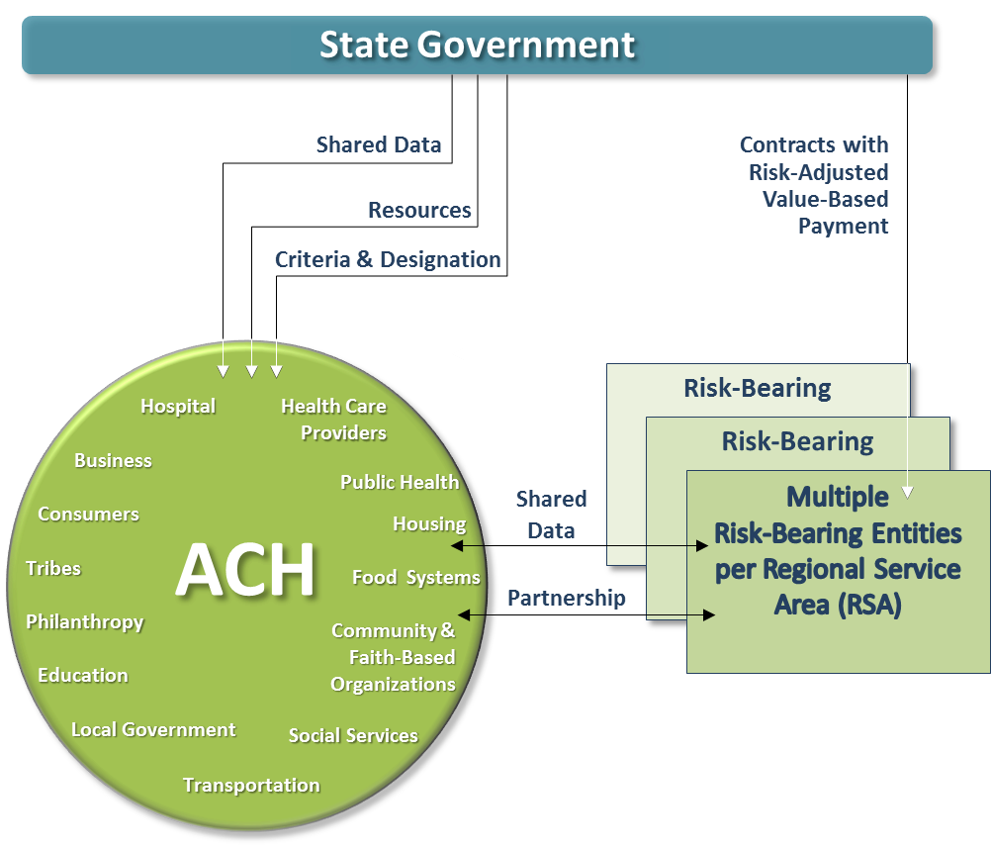

Source: HCA

