Care Transformation Workgroup Meeting
Date: 6/10/2015
Time: 10:00 AM – 11:30 AM
Location: Chelan-Douglas Health District, 200 Valley Mall Parkway, East Wenatchee
Board Room (2nd Floor)
Please park around the HD building perimeter, not in the dental office parking lot.
Conference Call: 760-569-7171
Conference Code: 924903
Please call in a few minutes before 10:00.
Agenda:
- Welcome
- Phone Conferencing Basics
- Team Member Introductions & One Goal of Participation
- Overview of Care Transformation Workgroup Task
- Workgroup Data Collection & Maintenance: National & regional data, asset inventory, document storage
- Project Selection Matrix
- Combining/Separating Care Transformation & Population Health Workgroups
- Next Meeting Date/Time – 2 Weeks – Please bring calendar availability for June 22 - 25.
Attachments to Agenda:
- FYI 2014 Grant Application Language
- FYI National, State, C-D County Data

Separate Attachments:
- Example of Logic Model – Diabetes Self-Management Education
- Diabetes Resources of Interest

Next Meeting Agenda:
- Project Selection Matrix and Selection
- Logic Model Development
- Asset Inventory Status

2014 Grant Application Language - Communities of Health (COH) Healthier Washington
Partners get involved in the COH process for various reasons, but lasting engagement usually occurs only when partners believe the process has a direct impact on their work or lives. A fully functioning ACH, with its many roles – including community health assessment and data analysis, payment reform, monitoring and evaluation, health improvement initiatives, provider education, etc. – will offer many partner engagement opportunities. In the meantime, however, attending meetings on state reform initiatives and the development of related plans is not enough to maintain engagement for the many partners who are not health policy wonks and do not see payment reform as a major business issue. Focused health improvement initiatives can provide compelling reasons for many community partners to stay involved.
During February of 2015, the Leadership Group will establish two initiative workgroups. The workgroups will include members from each NC-RSA county. Payers and other potential risk bearing entities will be invited to participate.
- One workgroup, the Care Transformation Workgroup, will develop a diabetes patient care improvement pilot project emphasizing a whole-person approach, the use of community as well as clinical resources to support effective care, and the integration of the physical and behavioral health aspects of treatment.
- The second workgroup, Population Health, p will develop a complementary community-based primary prevention effort intended to prevent diabetes in the first place.
Diabetes works well as the focus of these efforts because its treatment and prevention encompass behavioral health, physical health, the obesity epidemic, all age groups, and a wide range of partners. Improved diabetes care and prevention offer important opportunities for cost reduction. Both initiatives will build on existing community resources and projects to the extent possible. Because these initiatives will have to be developed without significant new resources, they are not intended to be full-scale region-wide interventions capable of major population health improvements, but they will be useful proof-of-concept projects that catalyze further partnership development and lay the groundwork for more definitive interventions in the future. Each initiative workgroup will develop during March, April and May of 2015 an implementation plan for consideration by the Governing Board at its initial meeting in May, 2015. The implementation plans will include clear metrics and objectives. The Board will adopt the plans or initiate any revisions considered necessary. The workgroups will implement these initiatives during the remainder of 2015 under the Governing Board’s oversight.
The fact that a significant proportion of NC-RSAs residents live in poverty has direct consequences for our local health care system. High poverty rates mean that patients with chronic disease are more likely to have non-medical challenges such as unstable housing. These challenges affect their capacity to effectively cope with a chronic disease, and make whole-person community-based care even more important. The high poverty rate also means that the payer mix in the area is heavily skewed toward Medicaid and Medicare. No RSA will be more strongly affected by HCA’s payment reform initiatives than this one. The importance of our Hispanic population also has implications for health transformation. Hispanic families and churches are often strong, providing social networks that can be an important asset in whole-person health care. At the same time, poverty is more common in the Hispanic community. The fact that many of our Hispanic residents came to this country recently, and with relatively low educational levels, also influences the way health care is delivered and prevention services must be organized.

National Data:
CDC National Diabetes Report: http://www.cdc.gov/diabetes/pubs/statsreport14/national-diabetes-report-web.pdf
WA State Data Examples:
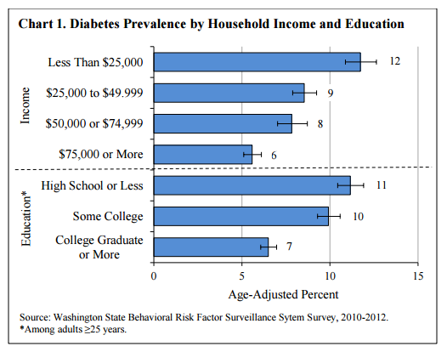
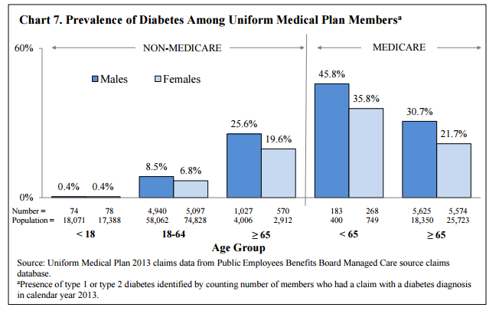
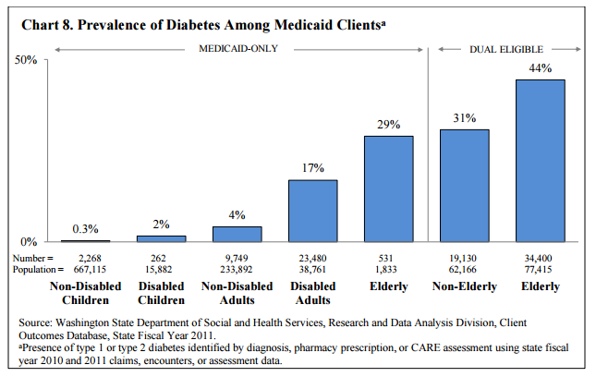
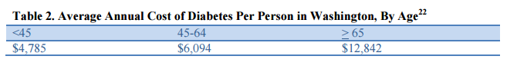
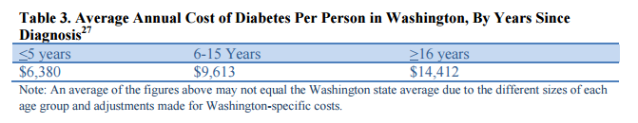
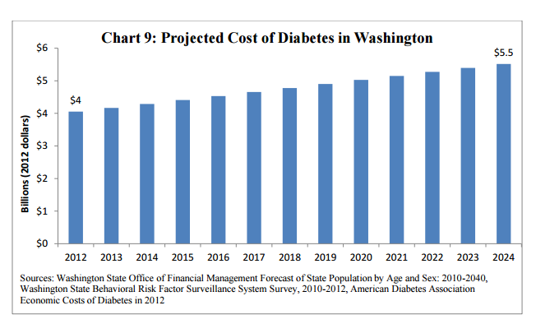

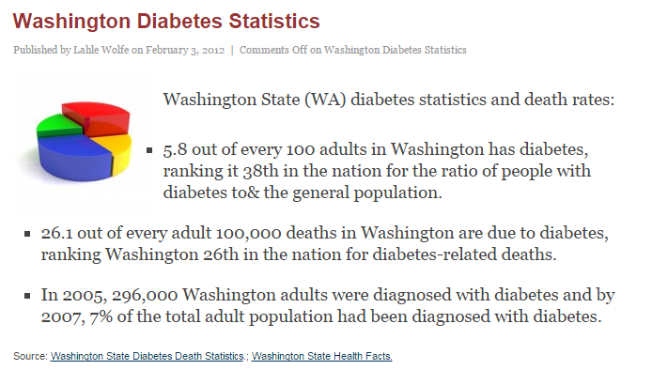

Chelan-Douglas Data:
