COMPREHENSIVE
- Serves approximately 600 clients per month, compared to around 450 per month in 2012.
- Around 2250 encounters per month, compared to around 1500 in 2012.
- Crisis services per month ranges from 7 to 31 in 2014 and 2013.
- New clients per month ranges from 39 to 68 in 2014.
KITTITAS VALLEY FIRE & RESCUE
- As of October 2, 2014, there have been 145 incidents that KVFR has responded to that have to do with drugs and alcohol this year (out of 2,889 total responses.)
  - 46 of them were CWU students (32%)
  - 102 were alcohol related, 2 were heroin-related, 6 were marijuana related, 2 were meth related, 24 were prescription drug related, 2 were spice related, 7 had multiple substances involved (mostly alcohol and prescription drugs.)
  - 85 of the incidents required transport
  - Age breakdown:

DEPARTMENT OF SOCIAL AND HEALTH SERVICES, 2011-2012
- Children services:
  - 417 CPS case management
  - 61 foster care placements
- Mental health:
  - 56 crisis services
  - 207 other outpatient

KITTITAS COUNTY SHERIFF’S OFFICE
- CPS & MH incidents: 15 in 2012, 19 in 2013
- Alcohol offenses: 14 in 2012, 17 in 2013, TOTAL for 2 years
  - 16 of 31 were in minors/juveniles
- Child Abuse & Neglect incidents: 9 in 2012, 8 in 2013
- Child molestation incidents: 7 in 2012, 3 in 2013
- Drug offenses: 66 in 2012, 24 in 2013
  - 55 marijuana possession (10 in 2013)
  - 11 paraphernalia possession
  - 7 other possession
  - 6 synthetics possession
  - 4 delivery
  - 3 sale/manufacture of marijuana
  - 2 sale/manufacture of synthetics
  - 1 cocaine possession
  - 1 equipment
- Mental health incidents: 33 in 2012, 26 in 2013
RISK AND PROTECTION PROFILE FOR SUBSTANCE ABUSE IN KITTITAS COUNTY, MAY 2014
DEPARTMENT OF SOCIAL AND HEALTH SERVICES, RESEARCH AND DATA ANALYSIS DIVISION
- Alcohol or drug related deaths: 41 of 275 in 2011, 37 of 264 in 2012
- Adults receiving state funded alcohol or drug services: 373 in 2011, 364 in 2012
- Alcohol related arrests: 483 in 2011, 375 in 2012
- Drug related arrests: 176 in 2011, 99 in 2012
- Children accepted for further CPS action: 348 in 2011, 291 in 2012
- Alcohol arrests in 10-17: 26 in 2011, 13 in 2012
- Drug arrests in 10-17: 16 in 2011, 11 in 2012
- Ages 10-17 in state funded alcohol or drug services: 24 in 2011, 38 in 2012
ELLENSBURG POLICE DEPARTMENT
 | 2011 | 2012 | 2013
Mental Health | 98 | 143 | 122
Substance Abuse arrests | Adult:109 JV: 20 | Adult:125 JV:27 | Adult:47 JV:11
DUI | Adult:91 JV:1 | Adult:105 JV:1 | Adult:85 JV:2
Child Abuse | 43 | 52 | 44

BRIGHT BEGINNINGS FOR KITTITAS COUNTY
- Early Head Start Program, 2013-2014, 74 children total
  - 1 child assessed for mental health, 1 referred
  - 6 families received mental health services
  - 3 families received substance abuse prevention services
  - 3 children in foster care at some point during the year
- Head Start Program, 2013-2014, 105 children total
  - 24 children obese (BMI at or above 95th percentile for age and sex)
  - 15 overweight
  - 3 children assessed for mental health, 1 referred
  - 3 families received mental health services
  - 2 families received substance abuse prevention services
  - 2 families received child abuse and neglect services
  - 3 children in foster care at some point during the year
OBESITY
- 1 in 5 adults don’t get any physical activity
- 26% of adults are obese, 35% have high blood pressure, and 38% have high cholesterol.
- One in 12 adults have diabetes.
- One in 20 adults have had a heart attack, coronary heart disease, or angina.
- Almost a 1/3 of 10th graders don’t get enough physical activity.
- One in eight 10th graders drink sugar sweetened beverages daily at school.
- 21% of 10th graders and 22% of 12th graders are either overweight or obese. 28% of 8th graders are either overweight or obese.
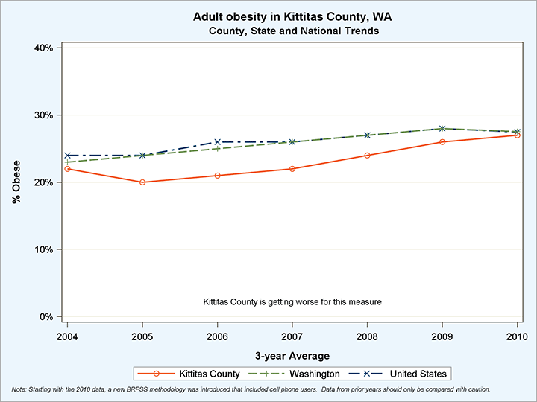
HEALTHY YOUTH SURVEY
- 26% of 10th graders and 43% of 12th graders report drinking in the past month.
- 17% of 10th graders and 28% of 12th graders report using marijuana in the past month.
- 4% of 10th graders and 7% of 12th graders report using painkillers to get high in the past month.
- 26% of 10th graders and 29% of 12th graders report feeling sad or hopeless for at least two weeks in the past year.
- 6% of 10th graders and 12% of 12th graders report attempting suicide in the past year.
ELLENSBURG SCHOOL DISTRICT, 2013-2014 SCHOOL YEAR, 3,001 STUDENTS
- 6 students with alcohol incidents resulting in expulsion or suspension
- 5 students with illicit drug incidents resulting in expulsion or suspension
KITTITAS SCHOOL DISTRICT, 2013-2014 SCHOOL YEAR, 667 STUDENTS
- 4 students with alcohol incidents resulting in expulsion or suspension
- 1 student with illicit drug incidents resulting in expulsion or suspension
CLE ELUM-ROSLYN SCHOOL DISTRICT, 2013-2014 SCHOOL YEAR, 924 STUDENTS
- 2 students with alcohol incidents resulting in expulsion or suspension
KITTITAS VALLEY HEALTHCARE
- 147 emergency department visits for potential substance abuse between July 1 2013 and June 30, 2014.
  - 99 primary diagnoses of alcohol abuse
  - 13 drug abuse (unspecified)
  - 11 drug withdrawal
  - 7 alcohol withdrawal
  - 6 amphetamine abuse
  - 3 cannabis abuse
  - 8 other

