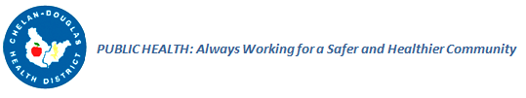

Diabetes Resources _________________________________________________________________

Websites

American Diabetes Association

http://www.diabetes.org/

Diabetes Training and Technical Assistance Center (DTTAC)

http://www.dttac.org/

Center for Disease Control and Prevention - Diabetes
http://www.cdc.gov/diabetes/home/
Juvenile Diabetes Research Foundation (JDRF)
http://jdrf.org/

Reports and Initiatives
2014 CDC National Diabetes Report

http://www.cdc.gov/diabetes/pubs/statsreport14/national-diabetes-report-web.pdf

2014 WA State Diabetes Epidemic & Action Report

http://www.doh.wa.gov/Portals/1/Documents/Pubs/345-342-DiabetesEpidemicActionReport.pdf

2014 Healthiest Next Generation Initiative

http://www.governor.wa.gov/issues/issues/health-care/healthiest-next-generation-initiative

2014 Healthier Washington Initiative

http://www.hca.wa.gov/hw/Pages/default.aspx

2013 Washington State Plan for Healthy Communities

http://www.doh.wa.gov/Portals/1/Documents/Pubs/140-073-WAStatePlanForHealthyCommunities.pdf

