Grant CHI Notes
April 21, 2015 9:00 a.m.-11:00 a.m.

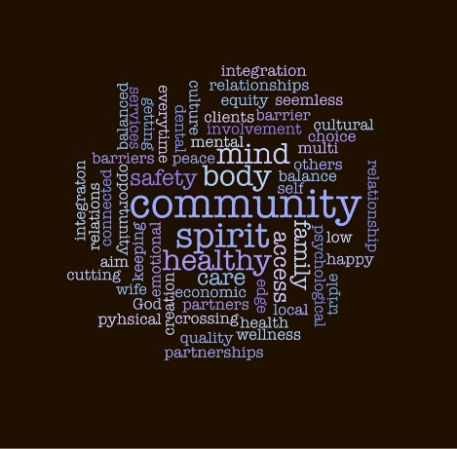
- Welcome/introductions-

- ACH Process Updates
Meeting participant comments:
- Development of trust is critical in these early stages
- Trust, accountability, transparency are all important moving forward. Concerns there is no transparency commitment in the draft document.
- The principle on the “role of voice” of the board doesn’t capture all of what is important at this level.
- All hospitals in Grant Co. are Public Hospital Districts. There needs to be a better/more inclusive “voice” for the rural communities. Please bring meetings to the rural communities.
- Can you (board seats) be required/create formality to engage “constituents” of who they represent to insure inclusivity of all voices?
- Re-evaluation is important in this process in 2015. It is important to do an evaluation/survey of constituents annually for the first few years.
- Concerns that Advisory Council won’t have power. There needs to be more formality in charter to give the Advisory Council more leverage/input to Governing Board. As an example, there should be policy written that will give AC nearly equal power to the Governing Board.
- Where does the consumer fit in?
- Concerns still remain about allocations of resources.
- Governing Board still gray. What are the distinctions between it and the Advisory Council?
- We don’t know the scope/significance of the Governing Body yet.
- No finance/reimbursement committee in the proposal.
- See it as a series of filters, such as Principles 2 & 3. See communication both ways as the heart and soul of the ACH.
- The benefits to the rural communities needs to show up here.
- Language of the representation on page 3 okay? Importance of Governing Board/Advisory Council is accountability.
- Should there be a limit to the number of representatives by county? Selection of seats is important consideration. Tom (Chair of Regional Hospital Council) spoke about the Washington State Hospital Association focus on a nominating committee that could balance the appointments to be fair.
- In the future we would hope this becomes less of a geographic representation and more accountability to the community/ACH as a whole.
- Initial representatives have the task of engaging the constituents.
- Equality will be important early in the process.
- Choosing from within stakeholder/constituency group can help in building trust.
- Why is Confluence the only healthcare system called out in the board membership? (Jeff responded with the explanation this is the only regionally reaching system in this RSA.)
- Where is representation of women/children? Veterans? Aging? Where would this occur? On the Governing Board or on the Advisory Council? If we are looking at population health we need to look at moms and kids.
- Primary Care can be representative of a “broad age” population.
- If we get too prescriptive we’ll “cut off our legs”.
- Suggestion for an outreach committee that can reach/have a presence within the individual constituents.
- Should the Advisory Council have a role in recommending the succession for Governing Board seats?
- There needs to be a communication plan going on at all times. Also a formal communication plan with County Commissioners/City Councils, etc.
- Women/Children/Poverty could be a position at large from groups that represent (Aging and Adult; Headstart;, etc.)
- Local Health District Updates/Projects requiring support of CHI-
Group agreed that quarterly CHI meetings are important in the communication of the ACH work moving forward. Group agreed that Community Choice/Grant Public Health District will schedule meetings for remainder of 2015 and then invite stakeholders to add these meetings to their calendars to ensure participation

Deb reported that Clinical Care workgroup will be convening soon and information will be distributed to those who have expressed interest in participating on these workgroups. Cathy Meuret from Chelan Douglas Health District will be facilitating both workgroups.

Deb will send a link to the Health Intiative online form for stakeholders to submit information about their programs that promote health. Stakeholders are encouraged to share the link with others who also have community health initiatives.

- Whole person health training
Stakeholders shared about ways they support/promote health through their own practices or through work.

Meeting documents can be accessed at: http://www.mydocvault.us/grant-coh.html
THANK YOU!

