Okanogan CHI
March 27, 2015 9:00 a.m.-11:00 a.m.
Okanogan Behavioral Healthcare
1007 Koala Drive, Omak

AGENDA

- Welcome/introductions-
Group introductions included personal definitions of “Whole Person Health” in 5 or fewer words. This word cloud represents the collective definition of the group:
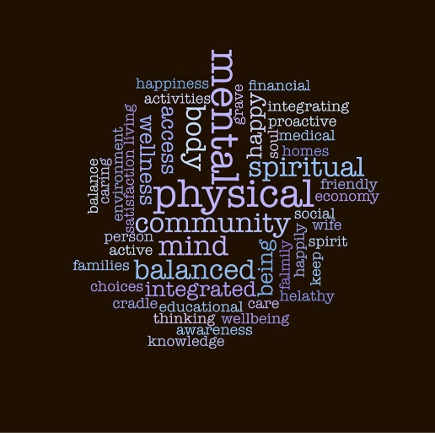
- ACH Process Updates-
An overview of the Design Community Grant was given by Jesus Hernandez. Peter Morgan and Jesus presented the proposed Governance Model and fielded questions and input from attendees. Three main questions arose:
- Are the payers/Health Plans voting members on this proposed model?
- Will the Executive committee membership be balanced? Will there be guidelines to ensure there won’t be sector dominance?
- Where do consumers fit into this model?
ACTION ITEM:
- Deb will send survey for input on the proposed governance model. Regional stakeholders are asked to respond to the survey by 04-14-15.

Deb Miller provided an overview of the scope/purpose of the county CHI meetings (document located in docvault) moving forward. The Okanogan meetings will be quarterly meetings.
ACTION ITEM:
- Deb will send survey by 04-03-2015 for determining the best day of week/time of day to hold meetings and then will use Doodle Poll to narrow down remaining meeting dates for 2015. Meeting participants will respond to polls in a timely manner so that remaining Okanogan CHI meeting schedule will be confirmed by 04-30-15.

- Local Health District Updates/Projects requiring support of CHI-
Lauri provided a brief presentation on the Okanogan County Health District perception survey (document located in docvault) as a refresher to the group. This was followed by a presentation by Cathy Meuret (Chelan Douglas Health District) (document located in docvault) on the local health indicators and sources of data available.

Deb Miller (Design Community staff) will be conducting an inventory of health initiatives in the NCACH. This inventory will help with the upcoming work of the regional Health Initiative Workgroups as well as future NCACH work.

ACTION ITEMS:
- Deb will email a link to a health inventory online submission form to the Okanogan CHI participants by 04-03-15. Meeting attendees will submit information by 04-30-15.
- Meeting attendees will review the current Okanogan CHI contact list (available in docvault) and will identify other important stakeholders to engage/invite to the process.

Cindy Button (Aero Methow) shared information with the group specific to pre-hospital care. She reported on the current legislation to approve non-emergent pre-hospital care by EMS is in the Governor’s office for signature. This legislation will be important in our region moving forward with the ACH planning process. It could provide alternatives to expensive transport of patients and provide EMS care to patients without added liability. She pointed to Yakima patient navigation program.

Michael Hassing reported a 24 hr. nurse advice line will be available in the Methow once FHC takes over in May.

Andi Ervin mentioned the Okanogan Community Coalition will be assessing the newest Healthy Youth Survey and a future state of the youth report.

- Whole person health discussion-
Nancy Warner facilitated a discussion on whole person health and engagement of not only the CHI participants, but the broader consumer population as well. She provided information about “A Picture of Health in NCW”, a joint project between IRIS and Community Choice that will discover and showcase stories about practices that contribute to whole person health.

The group participation portion of this discussion asked attendees to give an example of something they have done today, this week, or recently for their own health. The responses:
- Social and Family Time
- Music
- Walking/Running
- Cycling
- Physical Activities with my child/Soccer outdoors with daughter
- Sought help from Healthcare provider/Being Heard/Family time/Outdoors
- Exercise-Gardening
- Use technology to share exercise and healthy food goals with friends/family/others
- Coaching soccer
- Family dinner night 1/week
- Gardening (X4)
- Promote wellness to employees through program/invested self in program
- Physical exercise to get through grief
- Eat 1 meal together as family 1/day
- Read fiction to unwind
- Mindfulness practice (X3)
- Changed snack habits to healthier choices
- Community connection
- Reading fiction
- Reading to build empathy
- Exercise
- Sleeping well

- Next Steps-
Attendees will be asked to:
- Respond to email/doodle poll to determine best dates for future meetings (Action item above).
- Participate in Online survey regarding proposed Governance Model (Action item above).
- Participate in Health Initiative Inventory survey (Action item above).
- Review current stakeholder list and identify other stakeholders to invite to future meetings (Action item above).

Meeting documents can be accessed at: http://www.mydocvault.us/okanogan-coh.html
THANK YOU!

