Okanogan CHI
June 16, 2015 10:00 a.m.-12:00 a.m.
Okanogan Behavioral Healthcare
1007 Koala Drive, Omak

NOTES

- Welcome/introductions-15 minutes
(See attendance log for list of participants)
Attendees were asked to offer 3 words they would use to define a healthy community. The aggregated definition is represented by this word cloud:
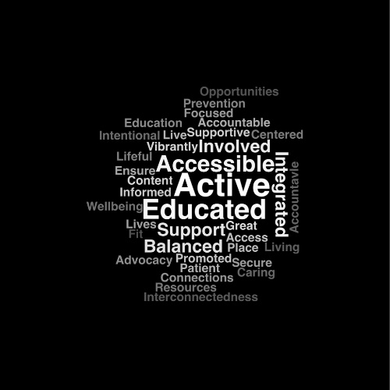
- ACH Process Updates-60 minutes
- Attendees reviewed the current list of NC ACH Board seats that have been filled. Questions regarding the process were:
  - How will geographic representation be assured? Will this be addressed in the governing board bylaws?
  - How are the “community” seats vetted? Is there opportunity for county CHI stakeholders to provide input?
  - How are potential board members targeted? What competencies are required for consideration or participation?
  - Is there any requirement for the Hispanic seat to be from a certain stakeholder group (i.e.: healthcare, etc.)?
- ACH Lead Group representatives talked about the process thus far and how we are all learning as we go. A survey about Governing Board development was distributed to a diverse group of stakeholders. Stakeholder input received was used in drafting and revising draft by-laws for the Board. The Governing Board will finalize the ACH by-laws. All questions/concerns/suggestions should be brought to the Lead Group/Governing Board for consideration. Follow up information will be sent to all stakeholders regarding the final decision making process for Governing Board development. Documents will also be available on the docvault document site.
- Skip Rosenthal reported on the Early Adopter decision from Okanogan County. There has been positive progress over the past month. Okanogan County is working toward integration (example: OBHC is moving toward co-locating with healthcare as well as education/7 districts). Skip reports that currently 90% of Okanogan County mental health clients and 75% of the chemical dependency clients are sent to Spokane for necessary care. County representatives felt that joining with Chelan-Douglas RSN now in the early adopter process would overwhelm the current system in place in Chelan-Douglas. However, they expressed interest in continuing to work strategically for eventual transition to the newly forming BHO.
- Cathy Meuret reported on the progress of the health initiative work groups. The Care Transformation team will be holding their second meeting, a work session with two anticipated products: designing collective processes/procedures for future NCACH activities, including a decision matrix for selection of a Care Transformation project. Volunteers for the Population Health workgroup, a group that will focus on a prevention project, will be contacted within the next two weeks to get the second team up and running.
- Local Health District Updates/Projects requiring support of CHI-45 minutes
- As the ACH process continues to move forward this group is encouraged to invite more stakeholders to the discussions. Discussion around other stakeholder groups that are missing. It was pointed out that county commissioners have been invited to meetings and have been sent information, but have not attended Okanogan CHI meetings. A discussion around finding ways to better engage and educate them about NCACH. Meeting attendees are encouraged to reach out and help with the engagement process for county commissioners as well as other stakeholder groups. Meeting attendees agreed of the importance of inclusion of county policy makers and tasked each other with using opportunities when they may have audience with commissioners to invite/engage them in the process. Skip Rosenthal identified himself as someone who works closely with the commissioners.
- Group suggestions on other stakeholders to engage in the process:
  - recreational groups
  - law enforcement
  - county coroner
  - faith based organizations
  - businesses
  - higher education
  - retail such as local grocers.
- Brainstorming of outreach/ACH presentation opportunities/sharing of upcoming events included:
  - Okanogan Highlands Alliance (OHA)
  - Okanogan County Injury Prevention is having an event on July 29th
  - ASSIST training coming up
- Whole person health-10 minutes
Nancy provided an update on A Picture of Health and facilitated discussion about how community actions are contributing to whole person health

Next meeting – September 15th 10:00-12:00 OBHC Conference Room

Meeting documents can be accessed at: http://www.mydocvault.us/okanogan-coh.html
THANK YOU!

