- How is quality of life perceived in Okanogan County?
  - Think of Maslow’s Hierarchy. Many people are at a basic level of quality related to physical health and safety. (see attached)
  - Environmental quality and the outdoors are important to many
  - Liberty and freedom from the intrusions of others and the government are important to many.
  - By quality of life, I do you also mean health? Some things came to mind:
    - Absence of disease…feeling good and not being in pain.
    - Sense of physical security and freedom from fear or undue stress
    - Sense of well being, feeling happy. Self esteem, self-confidence, interest in things around me, ambition and drive to accomplish things, desire to do them, a sense of achievement. Life having meaning or purpose beyond myself.
    - Being physically active, able to do the things I want to do
    - Economic well-being. Having enough money to do the things I want to do, within reason. Not wanting for the basics or important things in life
    - Social well-being: having friends, community, a sense of belonging
    - Being in relationship
- What is important in our community?
  - Our community is really many different sub-communities and they have different priorities. Perhaps this question is too broad. Certainly health is important.
  - Some of our politicians might suggest priorities like property rights, government regulation and overreach, cougar hunting and wolf predation are important.
- How can this group collectively impact the health of our valley?
  - Getting the questions right. It’s important to ask the right questions.
  - Clarify what we mean by terms like: Accountable, Community, and Health.
  - Continue to build on the work of others, present research, examples of improvement work from other places that can be used in our community. This should include both:
    - Examples of work (organizations, processes, collaborations, etc.) in our own communities as well as,
    - Examples from other counties, states, countries that could be adapted to our environment.
  - Build consensus around what is working and not working in our own world, what we have the opportunity to change
  - Create an inspiring vision of what is possible and what could be accomplished over the long haul. We need a picture of where we want to go, why and what it might be like to be there.
  - Identify a process for improvement to get to our vision with steps that are tangible, measurable, and meaningful. Use something like the lean methodology where we can experiment, learn continuously from what works and doesn’t work, and continue to adapt our processes.
- What assets do we have that can be used to improve community health?
  - We have a broad array of people and organizations who are working in the area of “health” broadly speaking who could be brought into this process (see attached document Exhibit 2)
- What is occurring or might occur that affects the health of our community?
  - I would ask each of the groups in the table on exhibit 2:
    - What are the trends you see that affect the work you do or the people you work with?
    - What activities do you conduct that improve the lives and health of individuals and the broader community?
    - How do you define and measure the effectiveness of your work and/or improvement in the people/populations you work with? (See table in exhibit 3. I think we need a clear sense of what defines both individual and population health and ways to track the results of inteventions)
    - Of the other groups listed, which group(s) do you think offer largest opportunity for shared work and collaboration?
    - What would you most like to see happen in your community that would support your work?
- What common themes do we share?
  - We understand that health is a multi-faceted topic and that good health is harder to define than poor health.
  - We want the best for our community
  - We believe that the way we’re doing things now could be improved with better collaboration and clearer goals.
  - We believe that too much is spent trying to repair poor health than in preventing poor health or promoting good health.

Exhibit 1
Maslow’s Hierachy of Needs
Where are we and our communities in this scale?
Is this what we mean by Health?

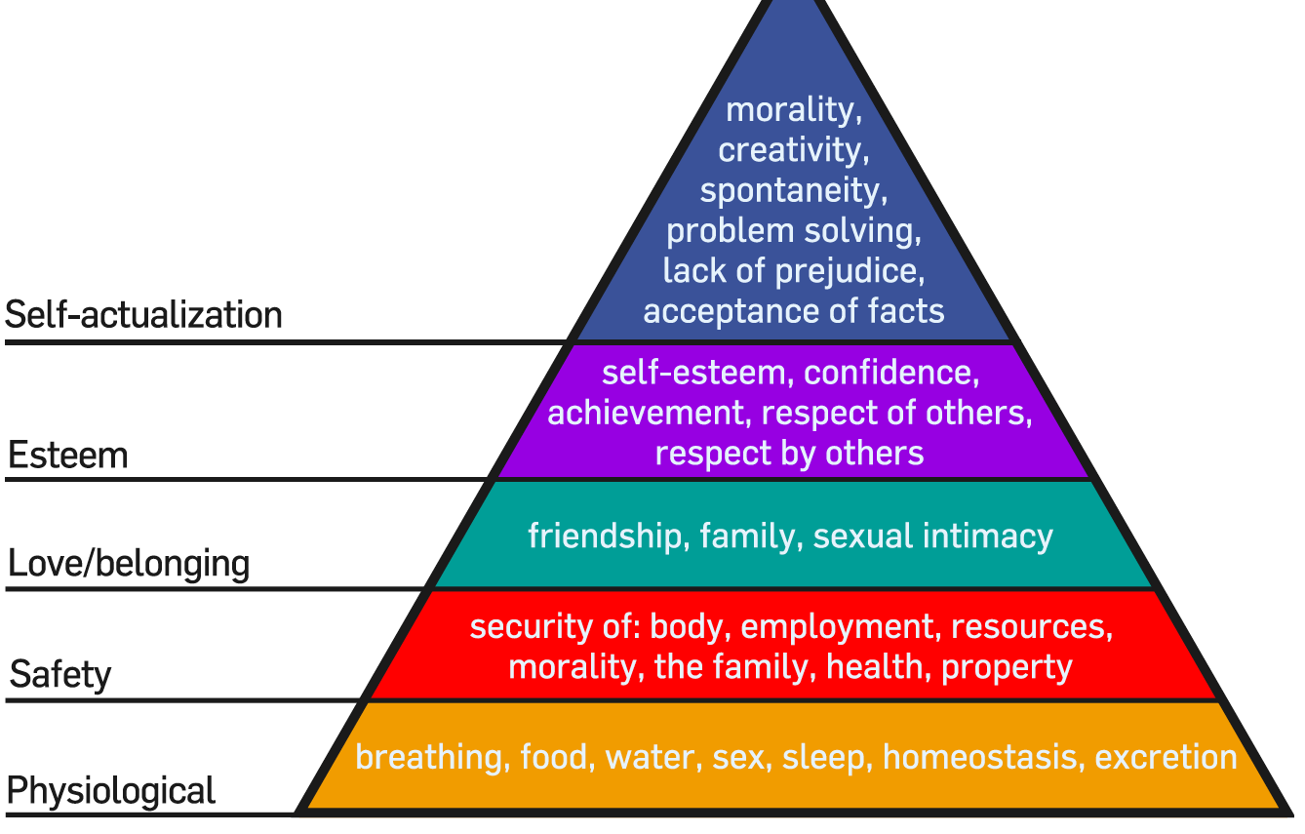

Exhibit 2
Stakeholders in the Health of the Community
Generally | In Methow Valley
Politicians & Government Agencies | Mayors & Town Councils, County Commissioners, Forest Service, DNR, DFW, WSDOT
Law Enforcement & Public Safety | Town Police, County Sherriff, Fire departments
Social Services | The Cove, Jamie's Place, Teen Center, Room One & related programs like (Red Shed, Lookout Coalition), Okanogan Community Action Council
Medical Community | Joe Jensen, Ann Diamond, Aero Methow, Family Health Centers, Hospitals, Naturopaths, Dentists
Behavioral Health | Counselors, OBHC, Ministers, Priests,
Educators | Tom Venable, School Superintendent, Teachers, Head Start, Church Schools, Home schoolers, Community School, Little Star (pre-school), Classroom in Bloom, Independent Learning Center, shop, welding, auto mechanics teachers, Big Brothers & Sisters, Boy & Girl Scouts, Campfire girls, mentors & tutors.
Public Health | Lauri Jones, Public Health Departments, Town, County & State Public Works for Roads, Bridges, Parks, Trails, Sewer, & Water
Food | Grocery Stores, Farmers, Restaurants, People who teach cooking and nutrition in schools, Farmer's Markets
Activators (organizations & People who promote recreation and activity) | Coaches, Sports Clubs, e.g.: Back Country Horsemen, ATV Club, Methow Trails (MVSTA), Evergreen Mountain Bike Club, Washington Bikes, Hunters, Ice Rink, Hot Air Balloon group.
Clubs (that build community and social good) | Kiwanis, Elks, Eagles, VFW, Ski clubs, book groups & clubs, travel groups
Faith & Spiritual Groups | Churches, Ashrams, Synagogues, Sangas, prayer groups, meditation groups,
Environmental Groups | Okanogan Highlands Alliance, Methow Conservancy, Methow Valley Community Council, Land Trusts, Trout Unlimited, Yakima Tribe, Fish Habitat Restoration Groups, Wildlife groups
Business Groups | Chambers of Commerce, TwispWorks
Arts Community | Galleries, Methow Arts Alliance, Merc Theatre, Orchestra, Chamber Music, Blues Festival,
