Care Transformation Workgroup
List of Potential Projects:
- Programa de Manejo Personal de la Diabetes (Spanish Diabetes Self-Management Program) – Stanford University

Programa de Manejo Personal de la Diabetes a community-based workshop given two and a half hours, once a week, for six weeks. Workshops are facilitated by two trained, certified and active Leaders, one or both of whom are non-health professionals with diabetes themselves. All workshops are given in Spanish without translators. Spanish-speaking people with type 2 diabetes attend the program in groups of 12 – 16. Participants may also bring a family member or friend.

Subjects covered include: 1) techniques to deal with the symptoms of diabetes, fatigue, pain, hyper/hypoglycemia, stress, and emotional problems such as depression, anger, fear and frustration; 2) appropriate exercise for maintaining and improving strength and endurance; 3) healthy eating 4) appropriate use of diabetes medications; and 5) working more effectively with health care providers. Participants make weekly action plans, share experiences, and help each other solve problems they encounter in creating and carrying out their self-management program.

- Better Choices, Better Health® Online Diabetes Self-Management Program – Stanford University

Online workshop for people Diabetes

Better Choices, Better Health®- Diabetes, previously named Self-Management @ Stanford Healthier Living with Diabetes, is an online workshop. It is based on the earlier Healthier Living with Ongoing Health Problems online program and the community-based Diabetes Self-Management Program. Groups of about 24 people with type 2 diabetes participate together. Workshops are facilitated by two trained facilitators, one or both of whom are peers with diabetes. Topics covered include: 1) healthy eating and menu planning, 2) managing blood glucose, 3) techniques to deal with problems such as fatigue, frustration and isolation, 4) appropriate exercise for managing blood glucose and for maintaining and improving strength, flexibility, and endurance, 5) appropriate use of medications, 6) communicating effectively with family, friends, and health professionals, 7) goal-setting, and, 8) disease-related problem solving.

Each workshop is 6 weeks with new lessons each week. Participants are asked to log on at their convenience 2-3 times each week for a total of 1-2 hours. Each participant in the workshop receives a copy of the companion book, Living a Healthy Life with Chronic Conditions, 4th Edition.

- Diabetes Self-Management Program – Stanford University

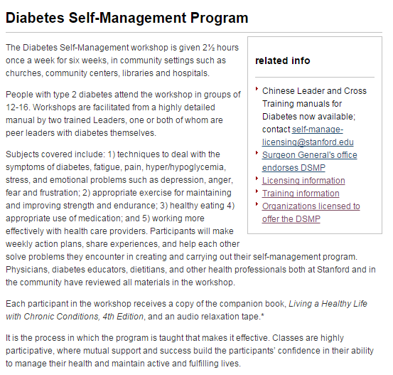

- Conduct in-person interviews with diabetic patients for their input on barriers they face to self-management or “doing the things their doctors are telling them to do”.
J Diabetes Sci Technol. 2011 May 1;5(3):723-30. Patient understanding of diabetes self-management: participatory decision-making in diabetes care.

- Conduct in-person interviews with diabetes residents of transitional housing (Bruce Hotel, Hospitality House, etc.) for their input on managing chronic disease when faced with homelessness and barriers to self-management.

