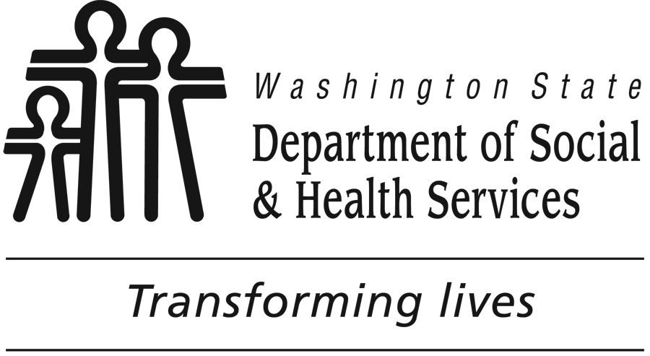

Social Marketing Planning Questions

This list of questions can help you get started in knowing what decisions to make as you move through the social marketing planning process. By knowing where you’ll be going, you can make decisions about what questions to answer during the problem description and what questions to ask in the formative research phase.

Answers may be found by collecting secondary data (literature, existing studies) or by conducting primary data collection. This is not a comprehensive list of all of the things you may potentially need to know, and you may not need to answer every question.

Problem/Health Issue
1. What is the problem?
2. What factors contribute to the problem? What causes or contributes to those factors?
3. Who is affected by the problem?
4. Who is most likely to change?
5. Who is able to change?
6. What evidence demonstrates there is a health problem? Do you have evidence to show the burden of the health problem in your community?

Target Audience
1. Who is the highest priority audience for your intervention?
2. What are some meaningful ways to distinguish one group from another?
3. Which audiences are your partners and stakeholders interested in reaching?
4. Which audiences do you or your partners have access to?

Narrowing the Target Audience:
6. Who are the segments in your target audience that you most need to reach? How do they differ from each other in their behavior?
7. Which audience segments are most affected by the problem? Or, who has the ability to change the environment of those affected by the problem?
8. Which audience segments are most likely and most willing to change their behavior?

Behavior
Selecting a Behavior:
1. What is the current behavior of your target audience?
2. What specific behavior are you going to address with your intervention?
3. What is the most realistic behavior change for the target audience to adopt?
4. What behavior can you feasibly try to change?
5. Will a change in this behavior actually affect the problem?
6. Should you select one behavior or a series of behaviors?

Understanding the Behavior in Your Target Audience:
7. What will the audience like about the new behavior? What are the consequences of change?
8. What might keep the audience from adopting the new behavior?
9. Are there environmental factors that play a role? What are they?
10. Are there policies or standards (for example, government laws or corporate policies) that either help or hinder the behavior change?
11. What recommendations or guidelines (i.e. HP 2010 objectives, clinical guidelines) exist related to your behavior?
12. What makes the audience’s current behavior easy? What makes the target behavior difficult?
13. Is it a measurable behavior? Is it observable? How would you measure it?
14. What happens on days where your audience is successful at doing the behavior? What’s different about those days? What made it easier to do it on that day?
15. What about days when they don’t do the behavior? What happens on those days? What is different?

Intervention Strategy
1. What strategies were used in interventions that have similar goals? Who was the target audience of those other interventions? How are the audiences similar to or different from your target audience?
2. Which strategies are promising?
3. Which strategies have not worked in the past?
4. Are there strategies that have been fully evaluated or draw on a base of evidence?

Additional planning questions within the intervention strategy section relate to the four P’s (marketing mix):
Product:
1. What does your target audience like about the behavior? (answers help you identify benefits)
2. What is appealing about it? (benefits)
3. What benefits can you reasonably offer to your audience?
4. What new behavior will be easiest for them to adopt?
5. What could they fit into their lives?
6. What kinds of things do they value in their life?
7. What does your audience believe about the behavior? Do they believe it will provide them with a certain benefit? What do they think, and how do they feel about that benefit? Note: These questions address theoretical constructs from the Social Cognitive Theory – outcome expectations and outcome expectancies.
8. Does the audience believe they can do the behavior? Note: Addresses theoretical construct from the Health Belief Model – self efficacy.
9. Where are they along the Stages of Change Model: no intention to change, thinking about changing, maintaining the healthy behavior already?
10. What social supports exist to help your audience adopt the behavior?

Price:
11. What does your audience not like about the behavior?
12. What is unappealing about it?
13. What things keep them from doing the behavior? (barriers/costs)
14. What costs/barriers do you have the ability to modify or reduce?
15. What will the audience need to give up to adopt the desired behavior? Note: The answer to this describes your competition.

Place:
16. Where does the audience do the desired behavior (or its competition)? Where are they thinking about the behavior? Where do they have the opportunity to try the desired behavior?
17. Where does the audience get information about the target behavior?
18. Where does the audience spend time?

Promotion:
19. What does your audience value in their life? What are their hopes and dreams? What do they want out of life?
20. Who influences/could influence your audience to do the behavior? To start it? To maintain it?
21. Who do they listen to about this behavior? Who is a credible source of information? Who is most motivating? Note: These questions can help you identify spokespersons and effective channels of information.
22. Who would be a credible source of information to the audience about the health topic or about the behavior?

Source: Adapted from the Centers for Disease Control and Prevention

